It’s a Square World After All
Using Grid-Based Map Analysis to Solve Spatial Problems

Joseph K. Berry

University of Denver – Geography Colloquium
Thursday, November 1, 2001, 4-5:00pm
BE209, Boettcher Building

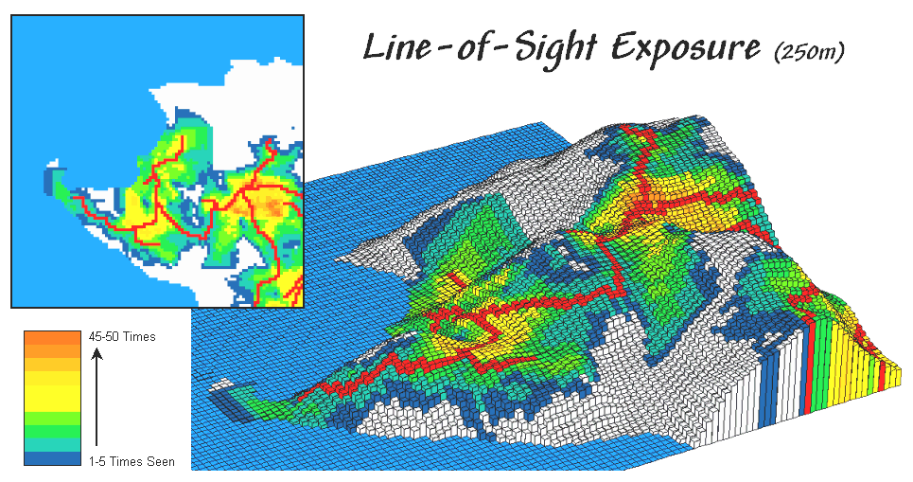
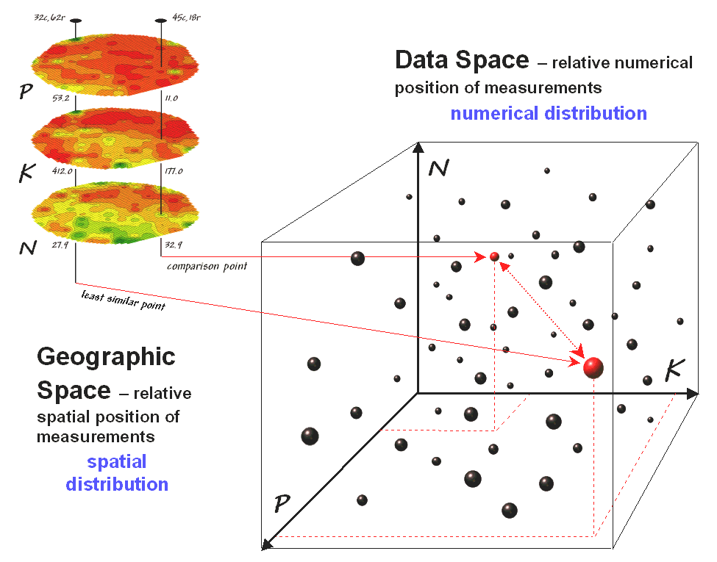
“The value of GIS technology is in its application.” Information has always been the cornerstone of effective decisions. Spatial information is particularly complex as it requires two descriptors— where is what. For hundreds of years the link between the two descriptors has been the traditional, manually drafted map. More recently, analysis of mapped data has become an important part of decision-making. This new perspective marks a turning point in the use of maps— from one emphasizing physical description of geographic space, to one of interpreting mapped data, and finally, to spatially characterizing and communicating management actions. The movement from where is what to why and so what has set the stage for entirely new concepts in planning and management of land. Spatial reasoning (thinking with maps) involves a wealth of analysis tools used to characterize spatial relationships, processes and interactions. The tools derive new maps based on spatial context, patterns, surface configuration, proximity, connectivity and flows. This presentation discusses and demonstrates many of grid-based analytical tools used in GIS modeling… applications that move well-beyond desktop mapping.
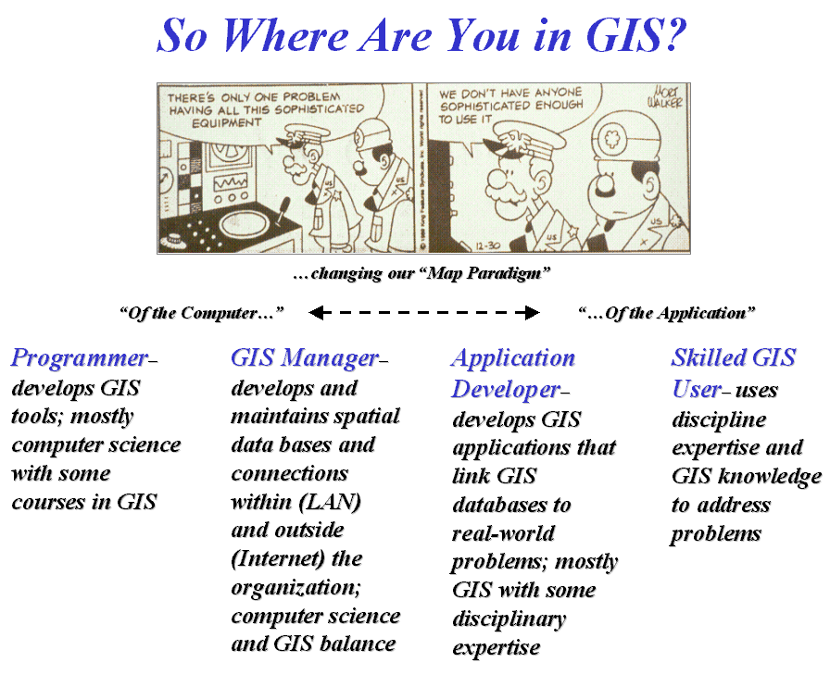
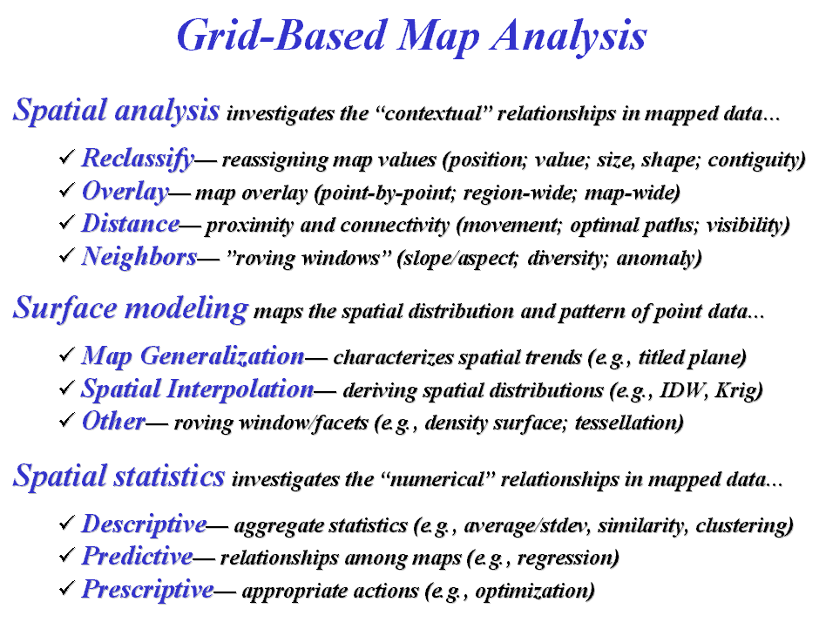

Joseph K. Berry is president of Berry and Associates // Spatial Information Systems, consultants and software developers in Geographic Information Systems (GIS) technology. He also serves as Special Projects Manager for Red Hen Systems, Special faculty member of Colorado State University and is the Keck Scholar in Geography at the University of Denver. He is the author of the Beyond Mapping column for GEOWorld, the column Inside the GIS Toolbox for ag/Innovator and has written over two hundred papers on the analytic capabilities of GIS. He has written the popular books Beyond Mapping and Spatial Reasoning and online resources Map Analysis and the Precision Farming Primer. He holds a B.S. degree in Forestry, an M.B.A. emphasizing operations research/finance, and a Ph.D. in remote sensing and land use planning.

Berry & Associates, 2000 South College Avenue, Suite 300, Fort Collins, Colorado 80525

Email: jberry@innovativegis.com; Web: www.innovativegi.com/basis

